API DESIGN FOR MICROSERVICES

A Research Report
Submitted in partial fulfillment of the Requirements for the award of the Degree of

MASTER OF SCIENCE (INFORMATION TECHNOLOGY)

By
Ahmed Dilshad Shaikh Seat Number: MIT251009
Under the esteemed guidance of
Asst. Prof. Ruchi Dubey

DEPARTMENT OF INFORMATION TECHNOLOGY

SHRI RAJASTHANI SEVA SANGH’S SMT.PARMESHWARIDEVI DURGADUTT TIBERWALA LIONS JUHU COLLEGE OF ARTS, COMMERCE & SCIENCE
(Affiliated to University of Mumbai) (Autonomous)
JB NAGAR, ANDHERI EAST, MUMBAI MAHARASHTRA - 400059 2025 - 26

TABLE OF CONTENTS

Sr. No. | Contents | Page No.
1 | INTRODUCTION | 3
2 | IMPORTANCE OF API DESIGN IN MICROSERVICES | 4
3 | API DESIGN TECHNIQUES | 5
4 | HOW API WORKS | 6
5 | CONCLUSION | 7

- INTRODUCTION
In microservices architecture, communication between services is one of the most important aspects of system design. Since a microservices-based application is composed of multiple independent services, there must be a proper mechanism through which these services can interact with each other. API design plays a vital role in enabling this communication by providing a structured and standardized way for services to exchange data and perform operations.
An Application Programming Interface (API) acts as a bridge between different services, allowing them to communicate without exposing internal implementation details. In microservices architecture, each service exposes its functionality through APIs, which are typically designed using web-based protocols such as HTTP. A well-designed API ensures that services remain loosely coupled, meaning that changes in one service do not directly affect others.
Furthermore, effective API design improves the scalability and maintainability of microservices systems. By following consistent design practices, developers can create APIs that are easy to understand, reuse, and extend. This becomes especially important in large-scale applications where multiple teams work on different services simultaneously.
In addition, modern API design focuses not only on data exchange but also on performance, security, and usability. Techniques such as RESTful APIs, message-based communication, and versioning help ensure that the system remains flexible and adaptable to future changes. As a result, API design has become a fundamental component in building efficient and reliable microservices applications


MPORTANCE OF API DESIGN IN MICROSERVICES
API design is crucial in microservices architecture because it directly affects how efficiently services communicate with each other. A well-structured API ensures seamless integration between services and reduces system complexity. It allows developers to build applications in a modular way, where each service can function independently.

Good API design enhances system scalability by allowing services to be updated or replaced without affecting the entire system. It also improves maintainability, as clearly defined APIs make it easier to debug and update services. Additionally, APIs enable integration with external systems, making applications more flexible and adaptable.

Another important aspect is that APIs improve collaboration among development teams. Since different teams may work on different microservices, well-defined APIs act as contracts that guide development and ensure consistency across the system.
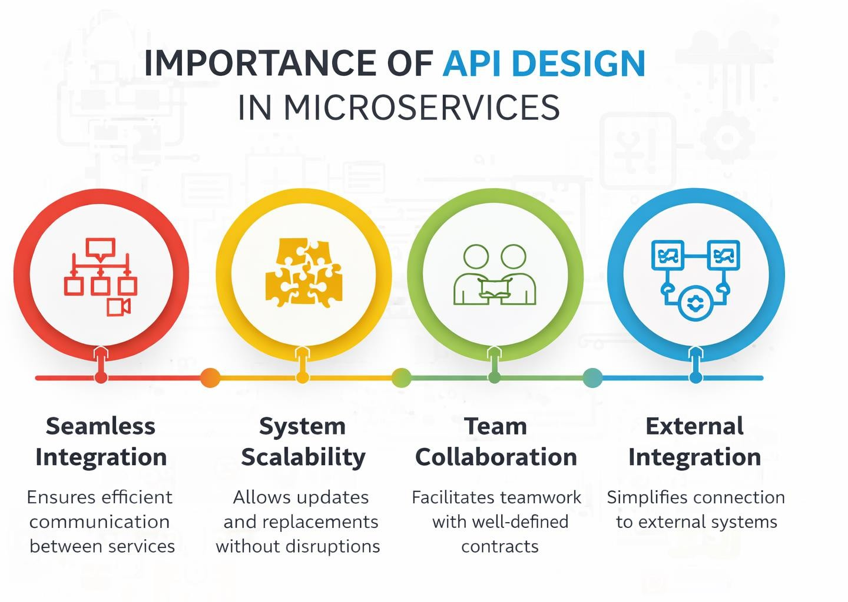

API DESIGN TECHNIQUES
API design in microservices involves several techniques that ensure efficient communication and system performance. One of the most commonly used approaches is RESTful API design, which uses standard HTTP methods such as GET, POST, PUT, and DELETE. REST APIs are simple, scalable, and widely supported, making them ideal for microservices.
Another important technique is message-based communication, where services communicate by sending and receiving messages instead of direct requests. This approach is useful for asynchronous operations and helps improve system performance and reliability.
Hypermedia-based APIs are also used in some cases, where APIs provide not only data but also possible actions that can be performed. This allows systems to become more dynamic and flexible. Additionally, API versioning is an important practice that helps manage changes without breaking existing functionality

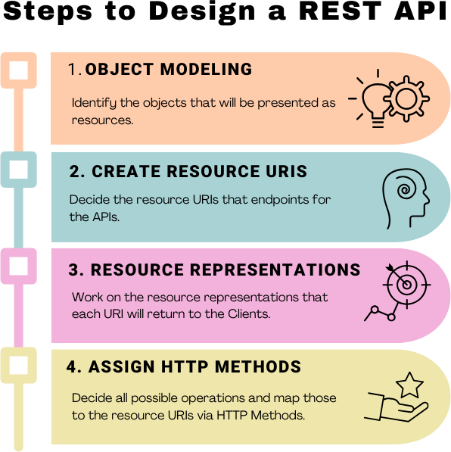

HOW API WORKS
An API works as a communication bridge between a client and a server. When a user interacts with an application, such as a mobile app or website, the client sends a request to the server through an API. This request is usually sent over the internet using standard protocols like HTTP. The API receives the request, processes it, and forwards it to the appropriate service or server.
Once the server processes the request, it sends back a response through the API. This response may include data such as user information, product details, or confirmation messages. The API ensures that the communication follows specific rules and formats, allowing different systems to interact smoothly without knowing each other's internal structure.
In microservices architecture, APIs are used for communication between different services. Each microservice exposes its functionality through APIs, allowing other services to access data and perform operations. This makes the system more flexible and scalable, as services can communicate efficiently without direct dependency.

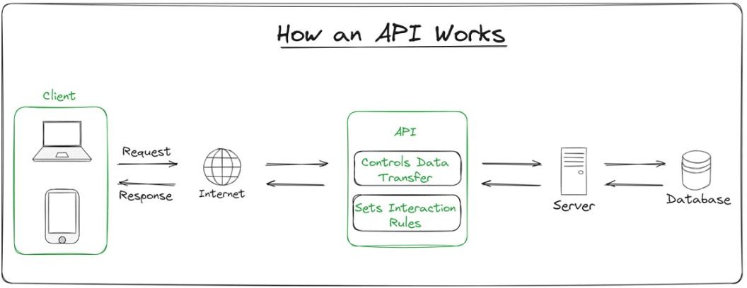

CONCLUSION
API design is a fundamental component of microservices architecture, as it enables communication between independent services. A well-designed API ensures that services can interact efficiently while maintaining flexibility and independence. It plays a significant role in improving system performance, scalability, and maintainability.
In this research paper, various aspects of API design were discussed, including its importance, techniques, and working. The study highlights how APIs act as a backbone of microservices systems by enabling smooth and reliable communication.
In conclusion, effective API design is essential for building modern applications based on microservices architecture. As technology continues to evolve, the role of APIs will become even more important in ensuring efficient and scalable system development.

References:
- https://www.geeksforgeeks.org/software-testing/what-is-an-api/
- https://favtutor.com/articles/api-guide-best-practices/
- https://restfulapi.net/

